**Software Requirements Specification (SRS) For Programmatic  Invoice**

**Table of Contents**

**1.  Introduction**

**1.1  Purpose**

**1.2  Scope**

**1.3  Definitions, Acronyms, and Abbreviations**

**1.4  References**

**1.5  Overview**

**2.  The Overall Description**

**2.1  Product Perspective**

**2.1.1 System Interfaces**

**2.1.2 Interfaces**

**2.1.3 Hardware Interfaces**

**2.1.4 Software Interfaces**

**2.1.5 Communications Interfaces**

**2.1.6 Memory Constraints**

**2.1.7 Operations**

**2.1.8 Site Adaptation Requirements**

**2.2  Product Functions**

**2.3  User Characteristics**

**2.4  Constraints**

**2.5 Assumptions and Dependencies**

**2.6 Apportioning of Requirement**

**3.  Specific Requirements**

**3.1 External interfaces Requirements**

**3.1.1  User Interface :**

1. **Login Screen**
2. **Register Screen**
3. **Dashboard  Screen**
4. **Product Details(CRUD)  Screen**
5. **Customer Details  Screen**
6. **Shop details  Screen**
7. **Edit user  Screen**
8. **Billing  Screen**
9. **Receipt Screen**

**3.1.2 Hardware Interfaces**

**3.1.3 Software Interfaces**

**3.1.4 Communications Interfaces**

**3.2 Software Product Features**

**3.2.1 project Information Maintenance**

* **Validity Checks**
* **Error Handling/ Response to Abnormal situations**
* **Sequencing Information**

**3.2.2 Employee Information Maintenance**

* **Validity Checks**
* **Sequencing Information**
* **Error Handling/ Response to Abnormal situations**

**3.2.3 product  Info Maintenance**

* **Validity Checks**
* **Sequencing Information**
* **Error Handling/ Response to Abnormal situations**

**3.2.3 Customer  Info Maintenance**

* **Validity Checks**
* **Sequencing Information**
* **Error Handling/ Response to Abnormal situations**

**3.2.4  product bill Generation**

* **Validity Checks**
* **Sequencing Information**
* **Error Handling/ Response to Abnormal situations**

**3.3 Performance Requirements**

**3.4 Design Constraints**

**3.5 Software System Attributes**

**3.5.1 Security**

**3.5.2 Maintainability**

**3.5.3 Portability**

**3.6 Logical Database Requirements**

**3.7 Other Requirement**

**1.  Introduction**

**1.1  Purpose**

This project is developed to manage the bill generation process in markets. Using this, shop owners or employees can easily generate the bill.

The main purpose of this bill management system project is developing a system that generates bills for the customers.

This billing software can solve many problems to manage retail efficiently. Retailers and quick service restaurant (QSR) owners need to take lots of features into consideration in order to make sure that the business runs smoothly and profitably. It is not only the everyday sales, but also the customer retention, sales, accounts and receivables, which needs proper management. An automated and intuitive billing solution makes things easier in such a situation.

This billing app is a complete solution that helps you bill, build customer loyalty, manage customers, payables and receivables, accounting, manage multiple stores and even more. This billing solution automates the business in such a way that you can gain control over every aspect of your business.

**1.2  Scope**

* The application is designed to maintain data related to the Store,
* Detail information about Customers.
* Detail information about Product and the items sold in shop.
* Detail information about Sales
* Generation of Bill

**1.3  Definitions, Acronyms, and Abbreviations**

* CRUD-Create,read,update,delete

**1.4  References**

* www.geeksforgeeks.com
* [www.javatpoints.com](http://www.javatpoints.com)
* [www.tutorialpoint.com](http://www.tutorialpoint.com)

CLASS NOTES

* Java  programming
* Software Engineering
* Algorithm Design and Analysis

**1.5  Overview**

The rest of this SRS document describes the various system requirements, interfaces, features and functionalities in detail.

**2.  The Overall Description**

The system will be responsible for storing details of products, employees & customers. In which product details will incorporate unique su code, name & retail price. Presence of unique su code will enable ease in updating, deleting along with fetching details of the required product.

Moreover, employee details will comprise a registration as well as a login page. Which will enable new employees to register themselves and at the same time  pre-registered employees will be able to login using a dedicated id and a password. Registered employees will be equipped with an authority to fetch & modify the details of a product during the sale. This will ultimately avert unauthorised individuals from accessing the software. Hence creating a secure environment.

Customer details will be stored along with billing so as to keep a track on transaction history. These details could be documented during the phase of billing. Customer details will consist of Name, Mobile no., E-mail,Date/Time of the purchase along with bill number and total amount ,Bill no,and employee id. This will help workers in future to generate adequate discounts while generating a bill.

**2.1  Product Perspective**

The need for software is felt, as the earlier system is manual thus requiring lot of paperwork and making it difficult to keep track of all the previous Sale,Product  and their Stock.

The system will give the advantage of eliminating paperwork and in turn errors caused by manual billing and it is a complete solution that helps you bill, build customer loyalty, manage customers, payables and receivables, accounting, manage multiple stores,provide security and even more.

**2.1.1 System Interfaces**

                 None

**2.1.2 User Interfaces:**

The application will have a user-friendly and menu based interface.

 Following screens will be provided:-

* Login Screen/ Register Screen:- This screen is responsible for requesting the client to enter  email and password. And also to verify the entered credentials from the past records.
* Dashboard  Screen:- It provides users to direct towards Billing, Products, Customer and Shop Details screens.
* Edit user  Screen:- Responsible for editing the user information stored in the database.
* Product Details (CRUD)  Screen:- Responsible to  Add, Delete, Update product records present in the database
* Customer Details  Screen:- Interface with the potential to display customer details stored in the database
* Shop details  Screen:- Interface projecting the official details of the shop, with capacity of updation.
* Billing  Screen:- Interface responsible for generating the bill.

**2.1.3 Hardware Interfaces**

| Processor | Pentium 500 MHz |
| --- | --- |
| RAM | 2 GB |
| Hard Drive | 4 GB Disk Drive Space(Available) |

**2.1.4 Software Interfaces**

| Database | MYSQL |
| --- | --- |
| API | JAVA JDK 16 |
| Other Tool And Technology | Java (JDK), Swings,AWT,MSWord  IDE used are NetBeans,Intellij. |

**2.1.5 Communications Interfaces**

* None

**2.1.6 Memory Constraints**

* At least 2 GB RAM and 4 GB space on the hard disk will be required for running the application.

**2.1.7 Operations**

* This product release will not cover any automated housekeeping aspects of the  Database. The DBA at the client site will be responsible for manually deleting old/non required data.Database backup and recovery will also have to be handled by DBA.

**2.1.8 Site Adaptation Requirements**

* The terminals at client sites will have to support the hardware and software interface specified in above sections.

**2.2  Product Functions**

The system will only allow  authentic users to access the software. Based upon the intention the user will be directed towards their desired destination. Depending upon the roles he/she will be able to access specific modules of the system.

* A summary of the major functions that the software will perform:
* A Login facility for enabling only authorised access to the system.
* Users are rendered with an option to Register themselves.
* Users can Delete, Update, Create,Edit or Read the data of products.
* Users can generate a bill along with an automated totalization of the cost.
* Users can make appropriate substitutes in the shop details.

**2.3  User Characteristics**

* Educational level: Basic understanding of English language.
* Technical expertise: Should be comfortable using general-purpose applications on a computer.

**2.4  Constraints**

* MySQL is used to define rules to allow or restrict what values can be stored in columns. The purpose of inducing constraints is to enforce the integrity of a database. MySQL is used to limit the type of data that can be inserted into a table.

* Due to limited features of DBMS being used, performance tuning features will not be applied to the queries and thus the system may become slow with the increase in number of records being stored.
* Due to limited features of DBMS being used, database auditing will also be provided.
* Employees at the store will have to implement a security policy to safeguard the store related information from being modified by unauthorized users (by means of gaining access to the backend database).

**2.5 Assumptions and Dependencies**

* Total amount generated cannot be blank.
* Different su code cannot be provided to the same product.

**2.6 Apportioning of Requirements**

* Not Required

**3.  Specific Requirements**

**3.1 External Interfaces**

**3.1.1 User Interface**

   The following screens will be provided:

**Login Screen:**

This will be the first page that will be projected. It will allow users to enter Email and Password. Moreover a Login button will be present, which on click will direct the user to the Dashboard interface after verifying credentials mentioned by the user.There is also a button named Create New Account for creating a new account and will load the register screen.

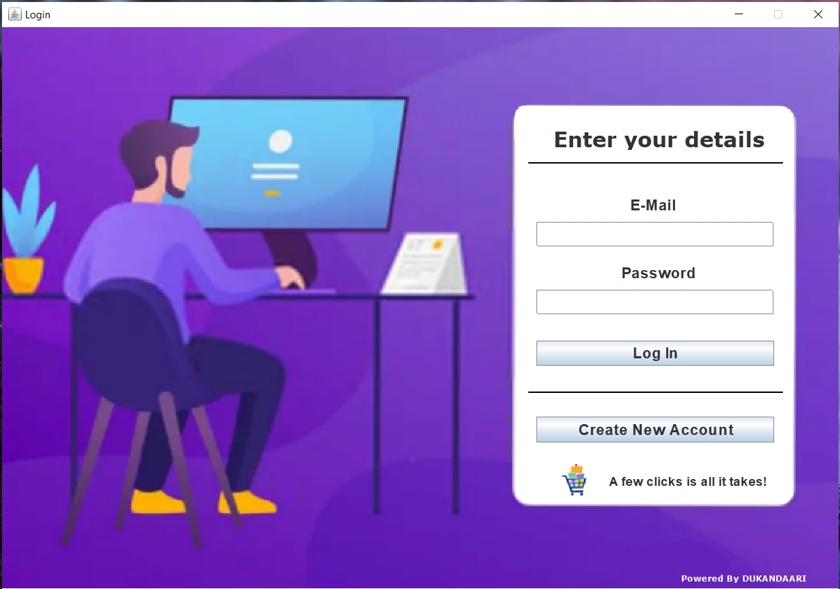

**Register Screen:**

This will also be one of the second screens that would be projected. This will include various fields such as

* Full Name
* Date of Birth
* Email
* Phone Number
* Gender
* Address
* Password
* Confirm Password

Also some buttons will be available

* Reset button:- This will erase all the details written by the user
* Submit button:- This will store the data in mySQL, to the table named ’Registration’.

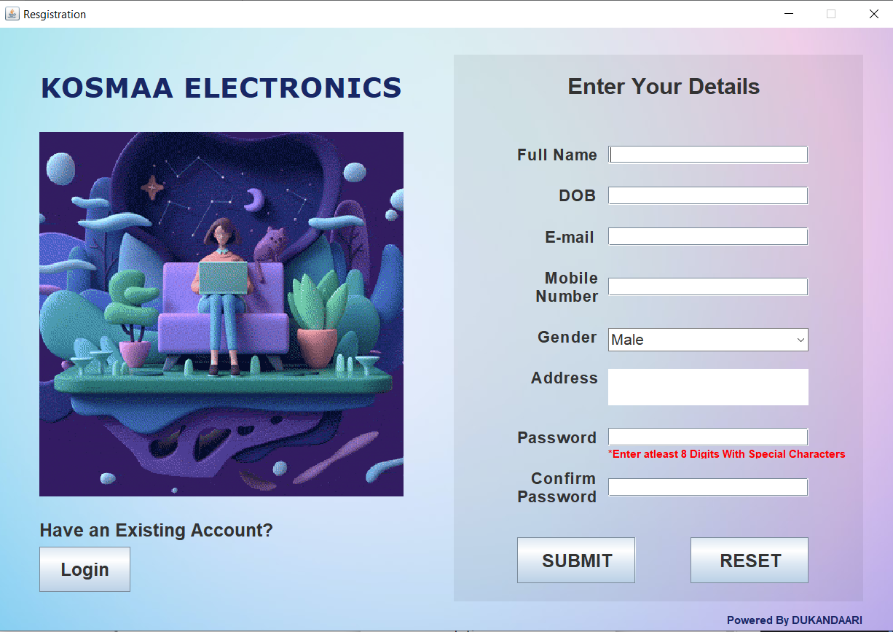

**Edit Profile Screen:**

As the name suggests this screen is evidently responsible to handle  erroneous information entered. This will include various fields such as

* Full Name
* Date of Birth
* Email
* Phone Number
* Gender
* Password
* Confirm Password

Also some buttons will be available

* Reset button:- This will erase all the details written by the user
* Submit button:- This will store the data in SQL, to the table named ’Registration’.

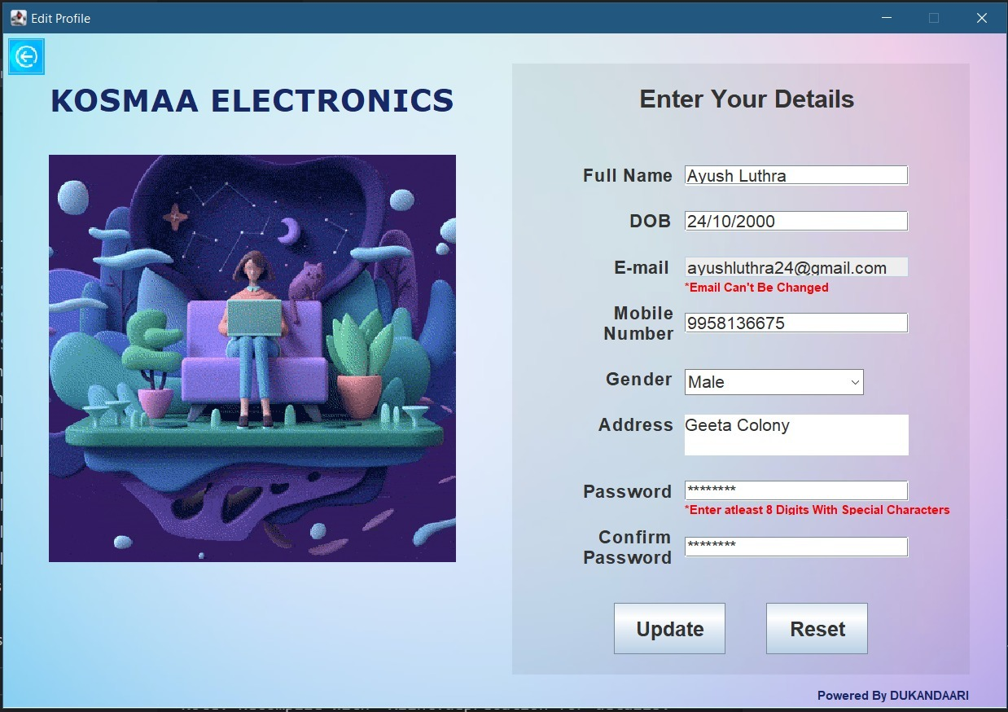

**Dashboard Screen:**

The mother of all screens which allows users to direct towards various screens such as Billing, Products, customer and Shop Details screens. This screen will include following buttons:-

* Generate Bill :-  this will direct towards Billing screen
* Products :- this will direct towards Product screen
* Customer :- this will direct towards Customer screen
* Shop Details :-this will direct towards Shop Details screen
* Edit profile:- This will direct towards the edit profile screen.

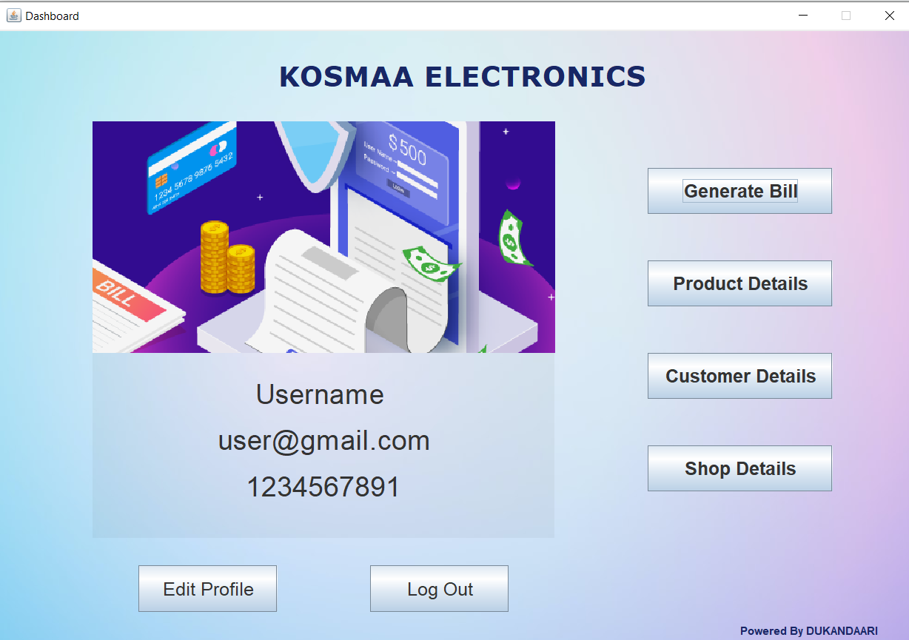

**Bill Screen:**

This screen helps the operator to generate the bill. This screen involves fields for customer details like:-

* Customer name
* Mobile number
* E-mail
* Address
* This screen involves fields for Product details like:-
* SU code
* Quantity

More some buttons are also present in this screen

* ADD:- Responsible to add product
* DELETE :- Responsible to delete product
* RECEIPT;-Responsible to generate bill

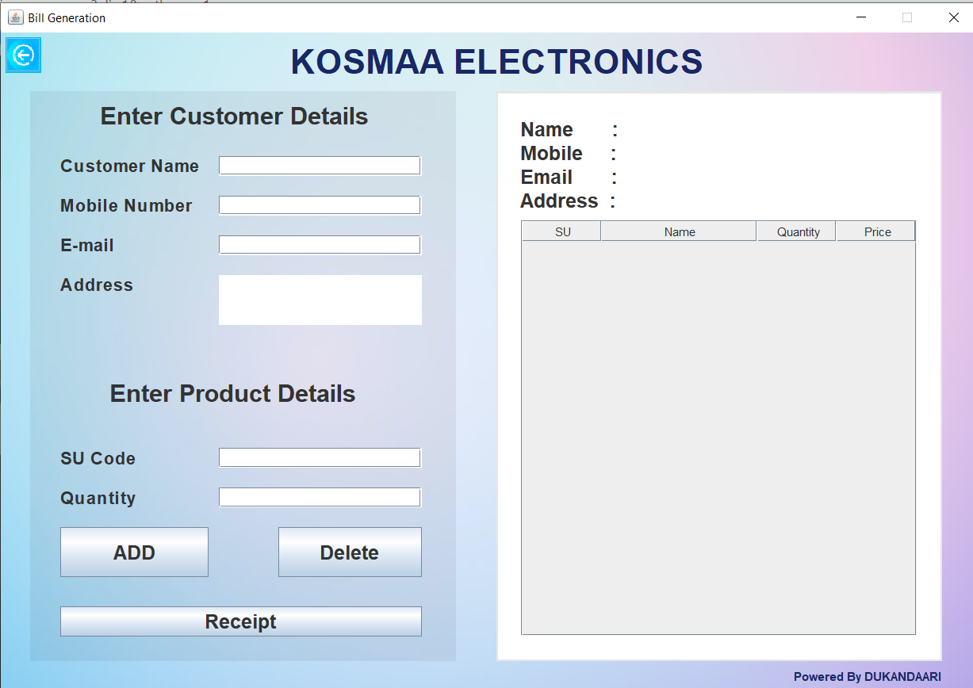

**Products Screen:**

This screen displays the list of products through means of a distinctly well organised table.Product can be specifically added, updated and deleted by providing

Su Code,Name and Price.  Moreover it also includes buttons like:-

* Add :- Responsible for adding products in the shop database
* Update :- Responsible for updating records.
* Delete :- Responsible to remove a product from database

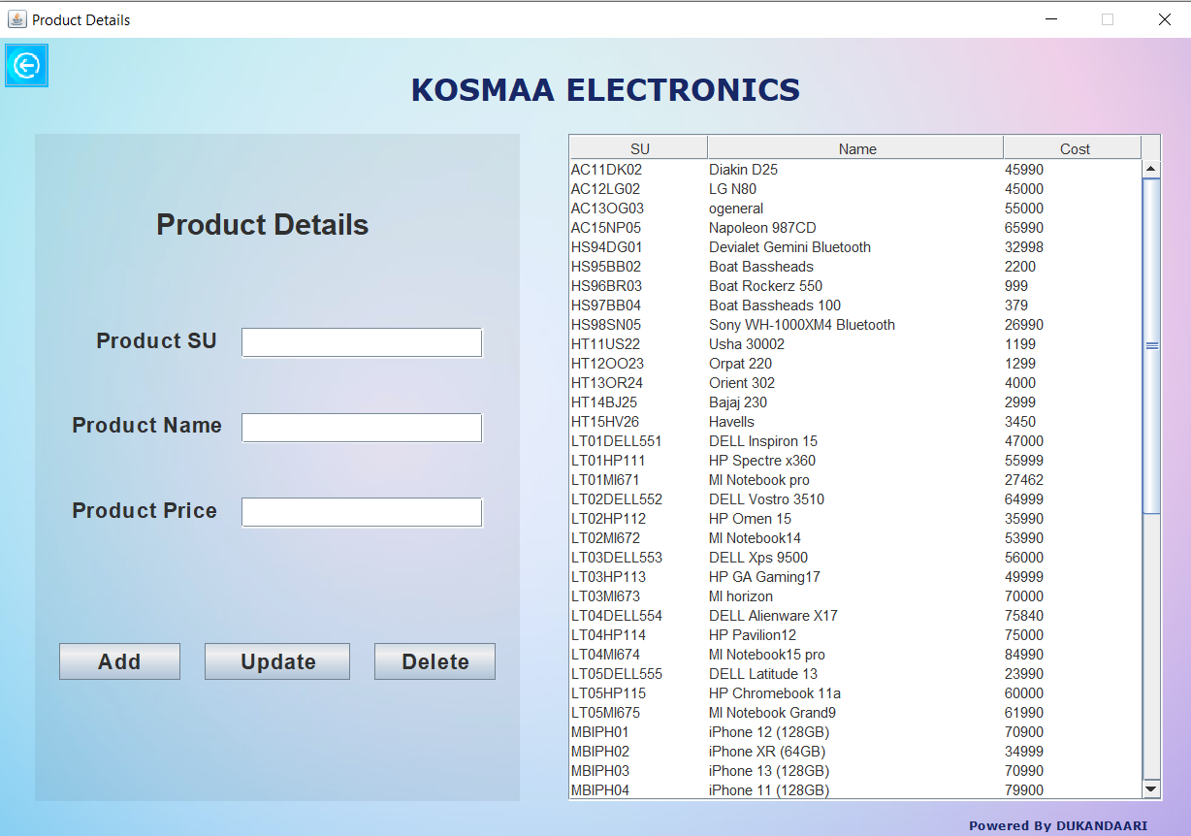

**Customer Screen:**

This screen directly interacts with the stored data of the customer.

This includes fields like

* Customer Name
* Bill number

These fields help in searching bills by customer name or bill number.

The button of “All Records” helps to fetch all maintained bill records.

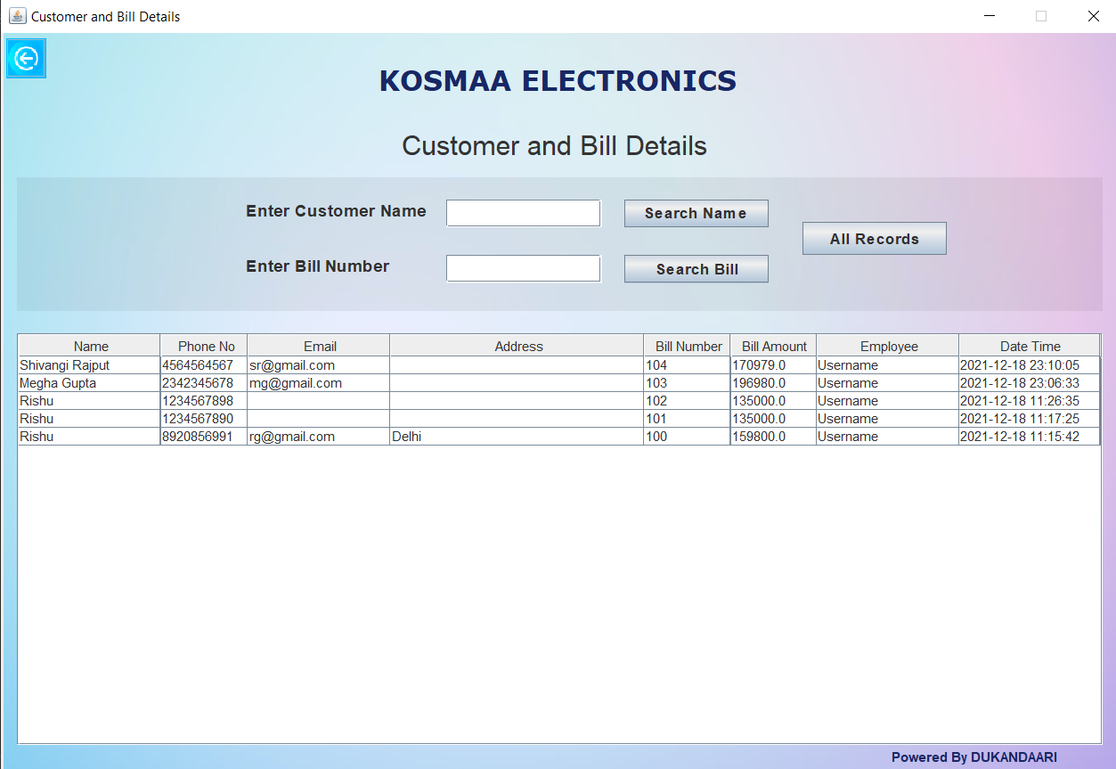

*Fetching records by entering customer name.

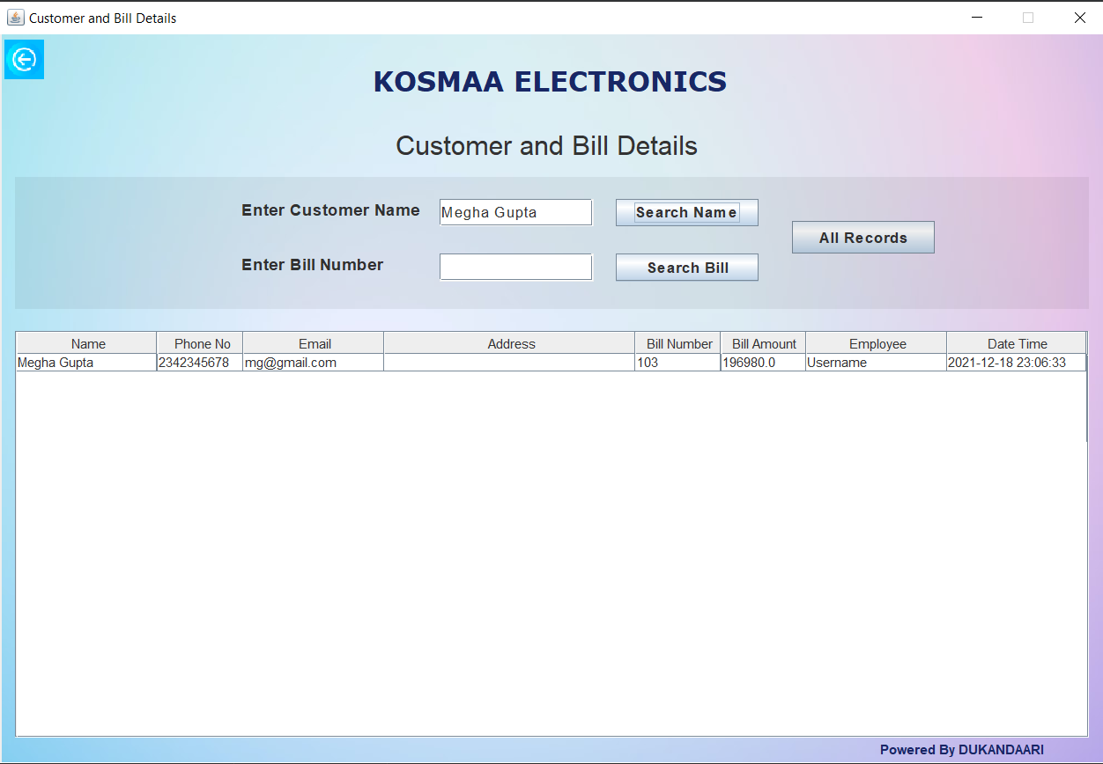

*Fetching records by entering bill number.

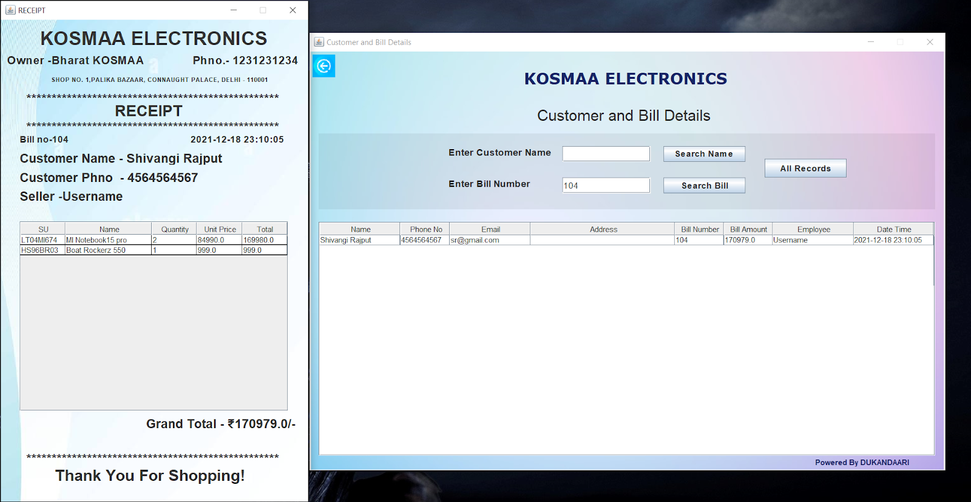

**Shop Details Screen:**

This screen proclaims the official information of the shop. Such as

* Owner Name
* Mobile number
* Shop Name
* Official Mail
* Address

There are three buttons: Check,Reset,Update available at the bottom of the page for verifying,changing and submission of the shop details provided by the owner.

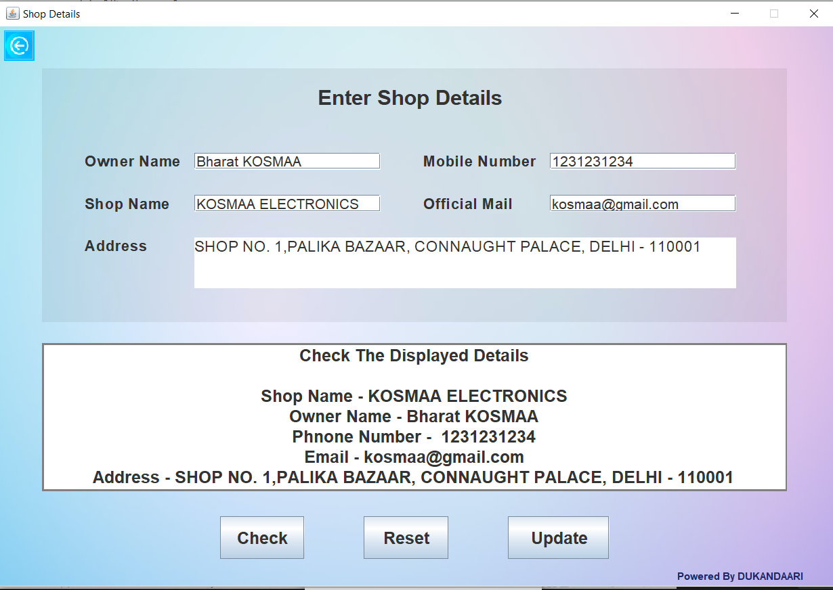

**Receipt screen:**

This screen directly interacts with employees to bill products for customers.This will include various fields related to products, customer and shop details.

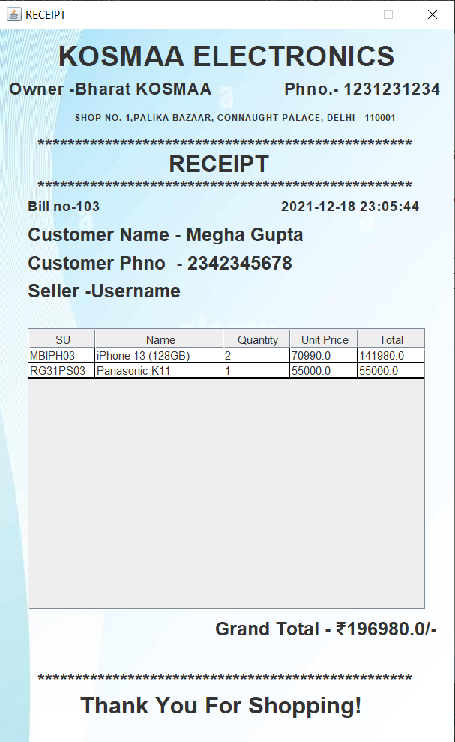

**3.2 Software Product Features**

**3.2.1 Project Information Maintenance**

**Description**

The system will be responsible for storing details of products, employees, shop & customers. In which product details will incorporate unique su code, name & retail price. Presence of unique su code will enable ease in updating, deleting along with fetching details of the required product. Employee details will comprise a registration as well as a login page. Which will enable new employees to register themselves and at the same time  pre-registered employees will be able to login using a dedicated E-mailand a password. Customer details will be stored along with billing so as to keep a track on transaction history. These details could be documented during the phase of billing.

**Validity Checks**

* Only users with role Data Entry Operator will be authorised to access the store Information Maintenance module.
* Uid (E-mail) and password field while logging in cannot be blank.
* Name, DOB, e-mail, phone no. and password cannot be left blank while registering.
* Customer name and contact no. cannot be blank.
* Product id and name will be unique for every product.
* Product name, SU, quantity , MRP , total amount cannot be blank while generating bill.
* Shop details including name, address and contact no. cannot be blank.

**Sequencing Information**

* Only users with role Data Entry Operator will be authorised to access the store information.

**Error Handling/ Response to Abnormal situations**

* If any of the above validations/sequencing flow does not hold true, appropriate error messages will be prompted to the user for doing the needful.

**3.2.2 Employee Information Maintenance**

**Description**

 Employee details will comprise a registration as well as a login page. Which will enable new employees to register themselves and at the same time  pre-registered employees will be able to login using a dedicated id and a password. Registered employees will be equipped with an authority to fetch & modify the details of a product during the sale. This will ultimately avert unauthorised individuals from accessing the software. Hence creating a secure environment.

**Validity Checks**

* Only users with role Data Entry Operator will be authorised to access the store Information Maintenance module.
* Uid (E-mail) and password field while logging in cannot be blank.
* Name, DOB, e-mail, phone no. and password cannot be left blank while registering.

**Sequencing Information**

* Registered employees  will be equipped with an authority to fetch & modify the details of a product during the sale. Unauthorised individuals will not be allowed to access the database and hence cannot manipulate it.Employee can also generate bills.

**Error Handling/ Response to Abnormal situations**

* If any of the above validations/sequencing flow does not hold true, appropriate error messages will be prompted to the user for doing the needful.

**3.2.3 Product  Info Maintenance**

**Description**

As it becomes very difficult to keep an eye on all the products that were available inside with gradual expansion of the shop. Moreover distinguishing regular and a new customer becomes complicated because all this was done based on recollection of memory.

* Product details consist of SU, name, retail price.Every product is given a unique SU code to store, fetch, update or delete its details

**Validity Checks**

* Product id and name will be unique for every product.
* Product id and name will not be blank.

**Sequencing Information**

* Presence of unique su code will enable ease in updating, deleting along with fetching details of the required product.

**Error Handling/ Response to Abnormal situations**

* If any of the above validations/sequencing flow does not hold true, appropriate error messages will be prompted to the user for doing the needful.

**3.2.4 Customer  Info Maintenance**

**Description**

Customer details will be stored along with billing so as to keep a track on transaction history. These details could be documented during the phase of billing.Customer details will consist of Name, Mobile no., E-mail,Date/Time of the purchase along with bill number and total amount ,Bill no,and employee id.This will help workers in future to generate adequate discounts while generating a bill.

**Validity Checks**

* Customer name cannot be blank.
* Customer contact no. cannot be blank.

**Sequencing Information**

* By entering customer name or bill number, users can view customer information or bill records.

**Error Handling/ Response to Abnormal situations**

* If any of the above validations/sequencing flow does not hold true, appropriate error messages will be prompted to the user for doing the needful.

**3.2.5  Product Bill Generation**

**Description**

The bill of all the selected products will be generated once the customer is done with buying items.The bill will contain the following details of the products i.e, product id, product name, product retail price and quantity.

**Validity Checks**

* Product id , name will be unique for every product.
* Product name, SU, quantity , MRP , total amount cannot be blank while generating bill.

**Sequencing Information**

* Bill will be generated only after the customer has bought all his/her required items. Total amount will be generated and the bill will be handed over to the customer by the employee.

**Error Handling/ Response to Abnormal situations**

* If any of the above validations/sequencing flow does not hold true, appropriate error messages will be prompted to the user for doing the needful.

**3.3 Performance Requirements**

* None

**3.4 Design Constraints**

* None

**3.5 Software System Attributes**

**3.5.1 Security**

The application will be password protected. Users will have to enter correct email, password in order to access the application.

**3.5.2 Maintainability**

The application will be designed in a maintainable manner. It will be easy to incorporate new requirements in the individual modules.

**3.5.3 Portability**

The application will be easily portable on any operating system, i.e., windows, linux or mac-os.

**3.6 Logical Database Requirements**

* Registration : Name, DOB, Email, Mobile_Number, Gender, Address, Password
* Login : SNO, UID, Date_Time
* ShopDetails: ID, Shop_Name, Owner_Name, Phone_number, Email, Shop_Address
* ProductRecords : SU, Product_Name, Cost
* Bill : Bill_No, SU, Product_Name, QTY, Cost
* CustomerRecords : Customer_Name, Customer_Phno, Customer_Email, Customer_Address, Seller, Total_Price, Purchase_Time, Bill_No

**Class Diagram for DataBase**

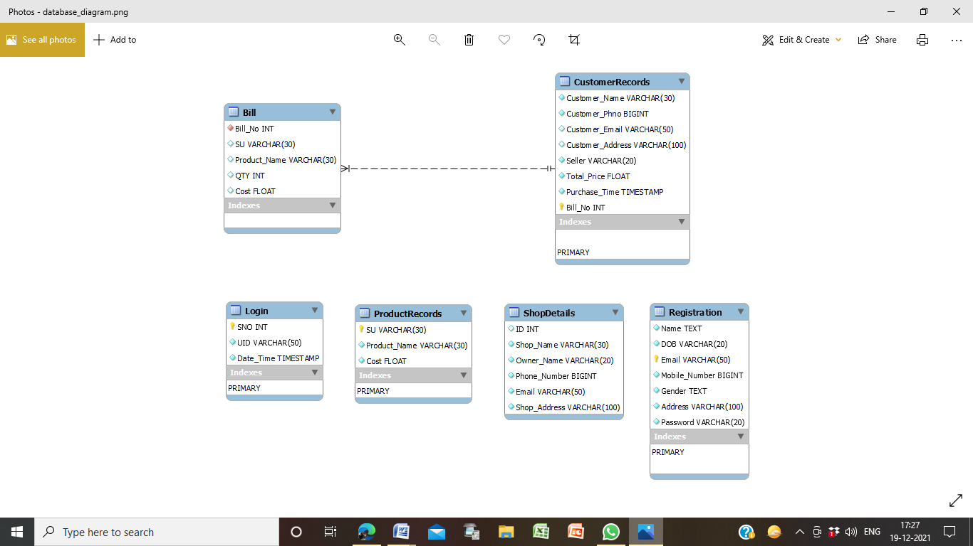

**3.7 Other Requirements**

* none